MEDTRACK DV
HOSPITAL OPERATIONS & PATIENT ANALYTICS

PREPARED BY: SHREYA MAHATO

PROGRAMME: BACHELOR OF COMPUTER APPLICATIONS (BCA)

INSTITUTION: KRISTU JAYANTI (Deemed to be University)
BENGALURU, KARNATAKA

TOOLS USED: Kaggle • Python • Jupyter Notebook • Pandas • Tableau • GitHub

PROJECT WORKFLOW: Data Collection → Data Cleaning → Data Refinement → Data Visualization → Dashboard Development → Insights

1.INTRODUCTION
1.1 Project Background
Hospitals generate large amounts of data through patient admissions, discharges, departments, wards, beds, diseases, billing, prescriptions, diagnostic tests, and payment activities. Analysing this information manually can make it difficult to identify operational patterns and understand how hospital resources are being utilized.
The MedTrack DV – Hospital Operations & Patient Analytics project was developed to transform hospital data into meaningful and interactive visual insights. The project focuses on analysing patient flow, departmental performance, hospital resources, bed utilization, billing, and other operational indicators through dashboards.

1.2 Problem Statement
Raw hospital datasets contain detailed information but are not always easy to interpret directly. Without proper data cleaning and visualization, important patterns such as admission trends, patient movement, length of stay, department workload, bed utilization, and payment behaviour can be difficult to identify.
Therefore, the project aims to refine the raw hospital dataset and develop interactive Tableau dashboards that present important hospital performance indicators in a clear and understandable form.

1.3 Project Objectives
The major objectives of the project are:
- To collect a suitable hospital dataset from Kaggle for analysis.
- To understand the structure and quality of the collected dataset.
- To clean and refine the raw data using Python and Pandas in Jupyter Notebook.
- To identify and prepare relevant fields required for analysis.
- To develop meaningful KPIs, charts, and interactive visualizations.
- To create four Tableau dashboards covering hospital overview, patient flow, department analytics, and resource utilization.
- To provide an interactive way to explore hospital operations using filters and dashboard navigation.
- To derive meaningful insights from the available hospital data.
1.4 Project Workflow
The complete project follows a structured data analytics workflow:
Kaggle Dataset → Data Understanding → Data Cleaning & Refinement in Jupyter Notebook → Cleaned Dataset → Tableau Visualization → Dashboard Development → Analysis & Insights
2.DATA COLLECTION
2.1 Data Source
The hospital dataset was collected from Kaggle, an online platform that provides datasets for data analysis and machine learning projects. The dataset was selected because it contains information relevant to hospital operations and patient management.

2.2 Dataset Description
The dataset contains 45,000 hospital admission records with information related to:
- Patient admissions and discharges
- Patient demographics
- Departments and wards
- Bed availability and status
- Diseases and disease categories
- Length of stay
- Billing and payment details
- Prescriptions and diagnostic tests

2.3 Purpose of Data Collection
The collected data provides the foundation for analysing patient flow, departmental performance, resource utilization, hospital occupancy, and financial activities through interactive dashboards.

Data Collection Flow
Kaggle → Raw Hospital Dataset → Jupyter Notebook for Refinement

3. DATA UNDERSTANDING
3.1 Dataset Structure
The collected hospital dataset contains 45,000 records and 41 columns. Each record represents a hospital admission and contains information about the patient, admission, department, ward, treatment, billing, and payment.

3.2 Major Data Categories
The important fields were grouped into the following categories:
- Patient Information: Patient ID, gender, date of birth, blood group, and city.
- Admission Information: Admission ID, admission date, discharge date, admission type, and admission status.
- Hospital Resources: Department, ward, bed, bed status, and total beds.
- Medical Information: Disease, disease category, prescriptions, drugs, diagnostic tests, and doctors.
- Financial Information: Total amount, insurance coverage, patient payable amount, room, drug, test, and procedure charges.
- Payment Information: Payment status and payment mode.

3.3 Initial Data Checks
Before visualization, the dataset was examined for missing values, duplicate records, incorrect data types, inconsistent categorical values, and other data-quality issues. These checks helped determine the preprocessing required before creating the final analytical dataset.

Key Observation
The dataset provided sufficient information to analyse patient flow, departmental performance, hospital resources, and financial activities, making it suitable for the planned Tableau dashboards

4.DATA CLEANING & REFINEMENT USING JUPYTER NOTEBOOK

The collected Kaggle dataset was refined using Python and Pandas in Jupyter Notebook before importing it into Tableau. The objective was to improve data quality, maintain consistency, and prepare the dataset for accurate analysis and visualization.
4.1 Loading and Inspecting the Dataset
The raw hospital dataset was imported into Jupyter Notebook using Pandas. Initial inspection was performed to understand the number of records, columns, data types, unique values, and overall structure of the dataset.

4.2 Checking Data Quality
The dataset was examined for common data-quality issues, including:
- Missing or null values
- Duplicate admission records
- Incorrect or inconsistent data types
- Duplicate or inconsistent categorical values
- Invalid or unexpected values in important fields

4.4 Data Validation
After cleaning, important relationships within the dataset were verified to ensure that the final results were reliable. This included checking admission counts, patient counts, bed capacity, occupied and available beds, and other important analytical values.

4.5 Preparing the Final Dataset
After the cleaning and validation process, the refined dataset was exported as:
hospital_cleaned.csv
This cleaned dataset was then used as the primary data source for creating the four interactive Tableau dashboards.

Outcome
The preprocessing stage transformed the raw Kaggle data into a structured, consistent, and analysis-ready dataset, reducing data-quality issues and ensuring that the KPIs and visualizations developed in Tableau were based on reliable data.

5.TOOLS & TECHNOLOGIES USED

The project used a combination of data collection, data-processing, visualization, and documentation tools.

5.1 Kaggle
Used as the source of the raw hospital dataset for the project.

5.2 Python
Used for data preprocessing, validation, and analysis during the data-refinement stage.

5.3 Jupyter Notebook
Used as the working environment for loading, inspecting, cleaning, refining, and validating the hospital dataset.

5.4 Pandas
Used for handling the dataset in Python, including data inspection, cleaning, transformation, and validation.

5.5 Tableau
Used to convert the cleaned dataset into interactive dashboards, KPIs, charts, filters, and visual analysis.

5.6 GitHub
Used for storing, organizing, documenting, and submitting the project work module-wise.

Overall Technology Workflow
Kaggle → Python/Pandas/Jupyter Notebook → Cleaned CSV → Tableau → GitHub

6.DATA VISUALIZATION USING TABLEAU

After the data was cleaned and saved as hospital_cleaned.csv, it was imported into Tableau for visualization and dashboard development.
The visualization stage focused on converting the processed hospital data into KPIs, charts, filters, and interactive dashboards that make hospital operations easier to understand.

6.1 Tableau Data Connection
The cleaned CSV file was connected to Tableau as the primary data source. The available patient, admission, department, ward, bed, medical, billing, and payment fields were reviewed before creating the visualizations.

6.2 KPI Development
Important performance indicators were created using Tableau calculations and aggregations, including:
- Total Admissions
- Average Length of Stay
- Readmission Rate
- Occupancy Rate
- Emergency Admission Percentage
- Total and Available Beds
- Department-level performance indicators
These KPIs provide a quick summary of the hospital's operational performance.
6.3 Dashboard Development
Four interactive dashboards were developed:
- Hospital Overview — provides an overall view of admissions, occupancy, patient stay, readmissions, and billing.
- Patient Flow — focuses on admissions, discharges, patient movement, length of stay, and disease categories.
- Department Analytics — compares department workload, revenue, length of stay, admission patterns, and efficiency.
- Resource Utilization — focuses on beds, occupancy, ward capacity, patient distribution, and payment modes.

6.4 Interactive Features
Common filters were added to allow users to dynamically explore the data by:
Admission Type, Department, Gender, Ward Type, and Admission Date.
Dashboard navigation buttons were also added to allow users to move easily between the four dashboards.

6.5 Creating Visualizations
Different chart types were selected according to the nature of the information being analysed:
- Line Charts — used for trends over time.
- Bar/Column Charts — used to compare categories and departments.
- Pie Charts — used to show proportions and distributions.
- Area Charts — used to show changes and comparisons over time.
- Treemaps — used to represent category-wise volume.
- Scatter Charts — used to compare multiple departmental measures.
- Funnel Charts — used for comparative distribution of selected measures.
- Waterfall Chart — used to represent changes across billing categories.

6.6 Dashboard Design
A consistent visual theme was maintained across all four dashboards using a dark navy background, contrasting text, colour-coded visualizations, KPI cards, and a common filter panel.

6.7 Dashboard Navigation
Navigation buttons were incorporated into the dashboards to allow users to move between the four analytical views:
Hospital Overview → Patient Flow → Department Analytics → Resource Utilization

7.HOSPITAL OVERVIEW
The Hospital Overview dashboard provides a high-level view of hospital operations by combining patient activity, bed utilization, readmissions, and financial information.
KPIs
1. Total Admissions — 45,000
Represents the total number of hospital admissions recorded in the dataset and provides an overall measure of patient activity.
2. Occupancy Rate — 65.06%
Shows the percentage of hospital beds being utilized, helping assess the current level of resource usage.
3. Average Length of Stay — 5.16 days
Represents the average number of days patients remain hospitalized, providing an indication of patient stay patterns.
4. Readmission Rate — 56.92%
Shows the proportion of patients who were admitted more than once, helping identify repeated hospital utilization.
5. Bed Utilization — 65.06%
Indicates the proportion of total available beds being utilized by patients.

Charts
1. Monthly Admissions Trend — Line Chart
Displays admission volumes month by month and helps identify changes and patterns in patient admissions over time.
2. Readmission Rate Trend — Line Chart
Tracks the readmission rate across months to observe how repeat admissions vary over time.
3. Bed Occupancy — Pie Chart
Compares occupied and available beds, giving a quick visual representation of hospital bed utilization.
4. Admissions by Department — Bar Chart
Compares admission volumes across departments and identifies departments with higher patient workloads.
5. Department Efficiency Comparison — Area Chart
Provides a comparative view of department efficiency and helps identify differences in departmental performance.
6. Patient Age Distribution — Column Chart
Shows the number of patients across different age groups, providing an overview of the hospital's patient demographics.
7. Payment Status Distribution — Pie Chart
Displays the proportion of paid and pending payments recorded in the hospital data.
8. Total Billing Amount by Department — Column Chart
Compares the total billing amount generated by each department.
9. Billing Amount by Payment Status — Waterfall Chart
Shows how the billing amount is distributed across different payment-status categories.
Filters
Admission Type, Department, Gender, Ward Type, and Admission Date are provided on the left side of the dashboard. These interactive filters allow users to customize the dashboard by selecting specific admission categories, departments, patient genders, ward types, or a particular date/date range. The selected filters are applied across the dashboard visuals, allowing users to focus on specific groups and examine their admission patterns, patient activity, bed utilization, readmissions, and billing information more closely.
Navigation
A navigation bar is provided at the top of the dashboard with links to Hospital Overview, Patient Flow, Department Analytics, and Resource Utilization. It allows users to move easily between the four dashboards and view different aspects of hospital operations without leaving the Tableau presentation.

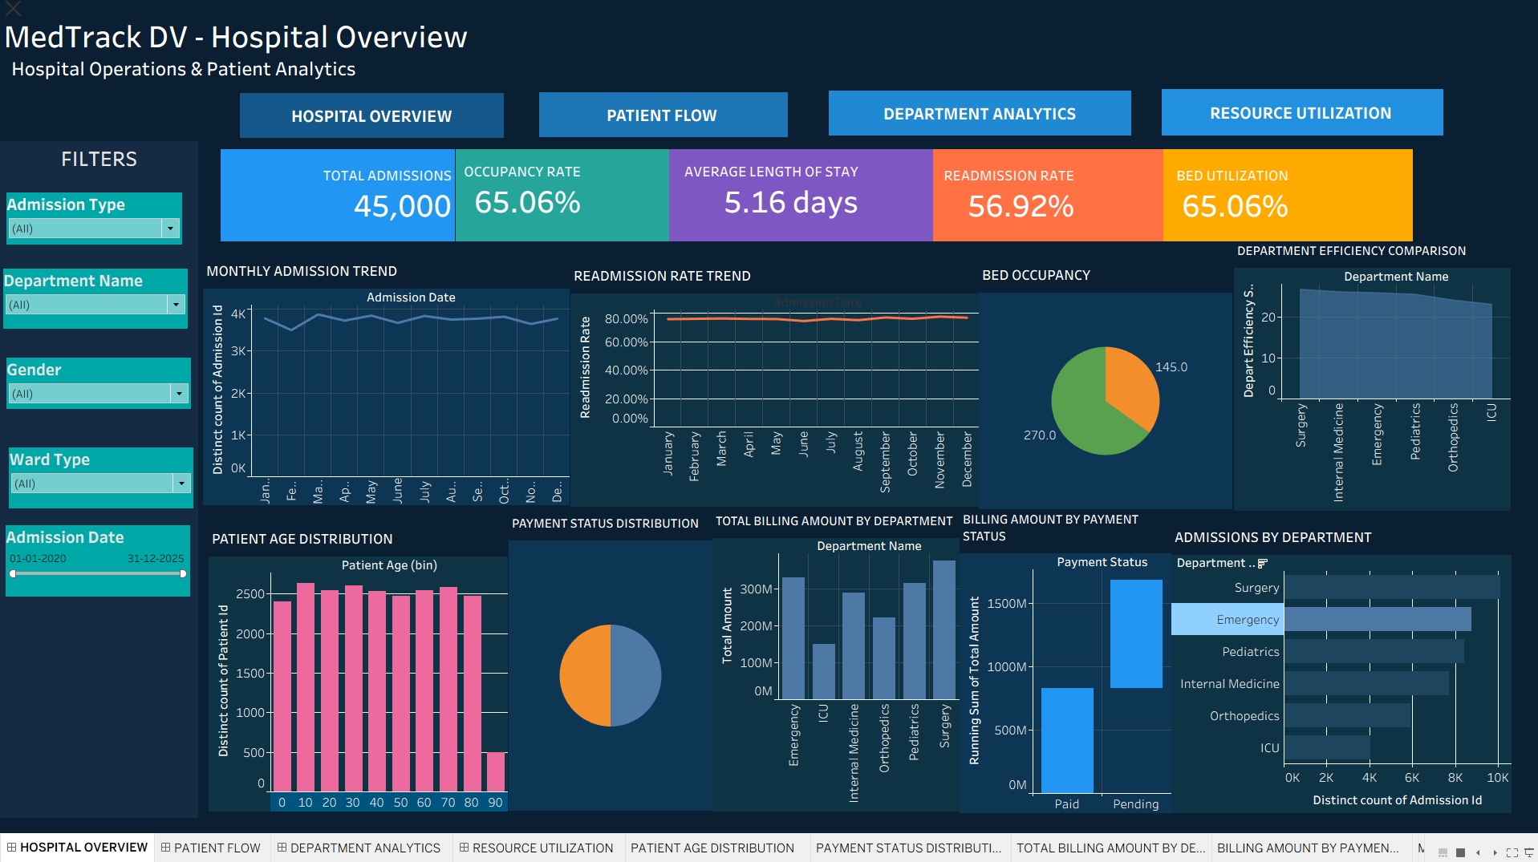
Fig:1

8.PATIENT FLOW
Patient Flow Dashboard
The Patient Flow Dashboard focuses on understanding how patients move through the hospital, from admission to discharge. It provides insights into admission patterns, patient volume, length of stay, gender distribution, and disease categories.

Key Performance Indicators
- Total Admissions — 45,000: Shows the total number of hospital admissions.
- Total Patients — 23,275: Represents the number of unique patients.
- Total Discharges — 45,000: Shows the total number of recorded discharges.
- Average Length of Stay — 5.16 days: Indicates the average duration of hospitalization.
- Emergency Admission — 40.17%: Shows the proportion of admissions classified as emergency cases.
- Peak Patient Load: Highlights the highest observed patient load used in the dashboard.

Visualizations
- Monthly Admissions vs Discharges — Line Chart: Compares admission and discharge patterns over time.
- Average Length of Stay by Department — Ribbon/Area Visualization: Compares the average stay across departments.
- Patient Distribution by Gender — Pie Chart: Shows the proportion of patients by gender.
- Length of Stay Distribution — Column Chart: Displays how frequently different lengths of stay occur.
- Average LOS by Admission Type — Horizontal Bar Chart: Compares hospitalization duration for different admission types.
- Patient Movement by Department — Horizontal Bar Chart: Shows patient volume across departments.
- Monthly Patient Load — Line Chart: Tracks unique patient volume over time.
- Admissions by Disease Category — Treemap: Represents admission volume across disease categories.

- Patient Load by Gender Over Time — Area Chart: Shows changes in patient volume by gender over time.

Filters
The dashboard includes Admission Type, Department, Gender, Ward Type, and Admission Date filters. These allow users to narrow the analysis and examine patient flow for specific admission categories, departments, genders, ward types, or time periods.

Navigation
The top navigation bar connects the Patient Flow dashboard with the other three dashboards—Hospital Overview, Department Analytics, and Resource Utilization—allowing users to switch between different areas of hospital analysis easily.

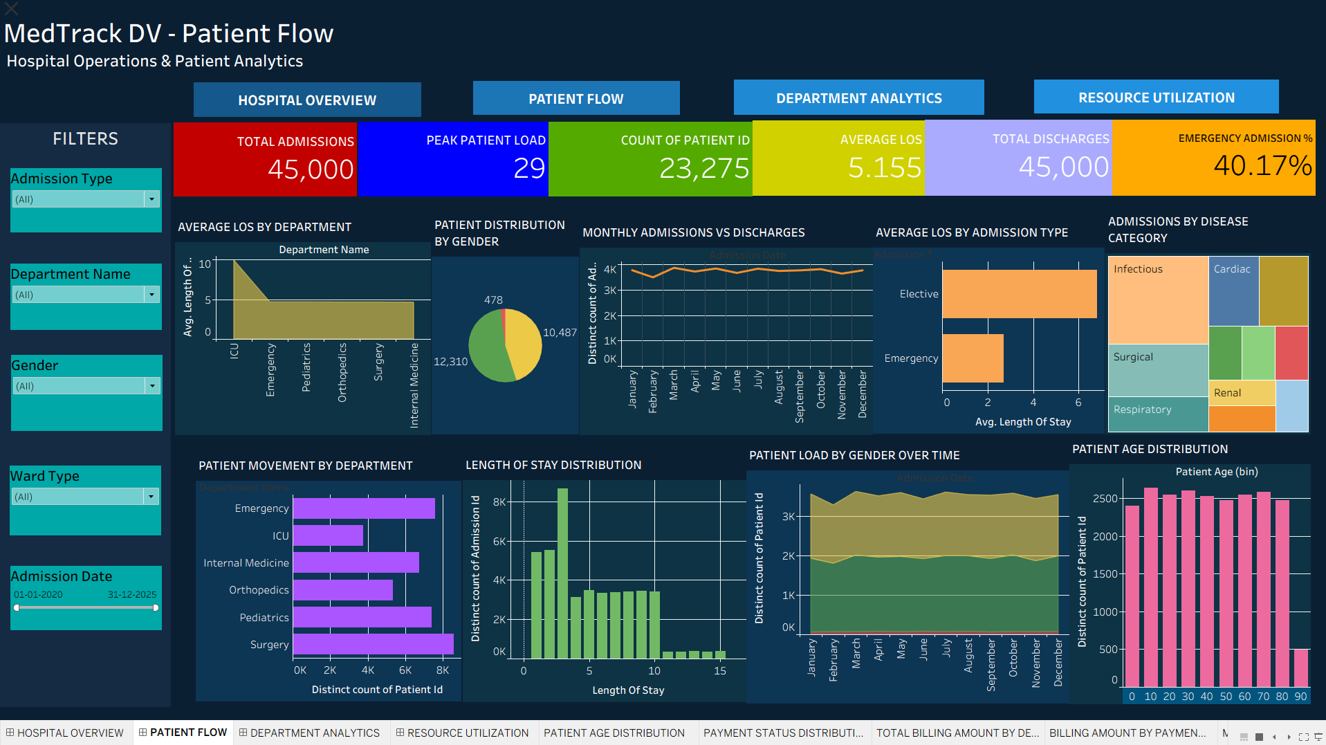
Fig:2

9.DEPARTMENT ANALYTICS

Department Analytics Dashboard
The Department Analytics Dashboard focuses on comparing the performance, patient volume, revenue, length of stay, and admission patterns of different hospital departments. It helps identify high-volume departments and departments with higher or lower operational performance.

Key Performance Indicators
- Total Departments — 6: Shows the number of major departments included in the analysis.
- Average Length of Stay — 5.16 days: Represents the overall average hospitalization duration.
- Top Volume Department — Surgery: Identifies the department with the highest admission volume.
- Highest LOS Department — ICU — 9.98 days: Shows the department with the highest average length of stay.
- Top Efficiency Department: Highlights the department ranked highest according to the efficiency metric used in the dashboard.

Visualizations
- Patient Volume by Department — Area Chart: Compares patient volume across departments.
- Department Revenue Share — Pie Chart: Shows each department's contribution to total hospital revenue.
- Average LOS by Department — Column Chart: Compares average length of stay between departments.
- Admission Type Distribution — Donut Chart: Shows the distribution of elective and emergency admissions.
- Admission Rate by Department — Horizontal Bar Chart: Compares admission volumes across departments.
- Department Comparison — Scatter Plot: Compares admissions, average LOS, and department efficiency together.
- Gender Distribution — Column Chart: Shows patient distribution by gender.

Filters
The dashboard uses Admission Type, Department, Gender, Ward Type, and Admission Date filters. These allow users to focus the departmental analysis on particular patient groups, admission categories, departments, ward types, or time periods.

Navigation
The navigation bar at the top connects Department Analytics with Hospital Overview, Patient Flow, and Resource Utilization, allowing users to move between the four dashboards and compare different areas of hospital performance.

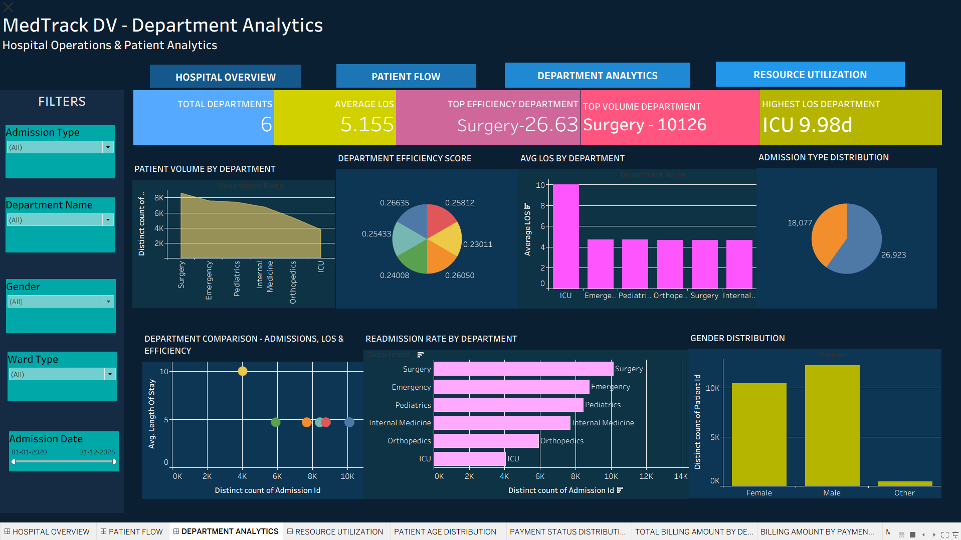
Fig:3

10.RESOURCE UTILIZATION

Resource Utilization Dashboard
The Resource Utilization Dashboard focuses on the availability and usage of hospital resources, particularly beds. It helps monitor bed capacity, occupancy, ward-level availability, admission patterns, and payment modes.

Key Performance Indicators
- Total Beds — 415: Represents the total bed capacity included in the hospital dataset.
- Occupied Beds — 270: Shows the number of beds considered occupied.
- Available Beds — 145: Shows the number of beds currently available.
- Bed Utilization — 65.06%: Represents the proportion of total bed capacity being utilized.

Visualizations
- Bed Availability by Ward — Horizontal Bar Chart: Compares the number of available beds across wards.
- Occupancy Rate Trend — Line Chart: Shows changes in bed occupancy over time.
- Bed Count by Ward — Column Chart: Compares the total bed capacity of different wards.
- Admission by Type — Funnel Chart: Shows the distribution of admissions by admission type.
- Bed Occupancy by Department — Funnel Chart: Compares occupied-bed levels across departments.
- Bed Status Distribution — Pie Chart: Displays the proportion of occupied and available beds.
- Patient Distribution by Ward Type — Treemap: Shows patient volume across different ward types.
- Payment Mode Distribution — Pie Chart: Represents the distribution of admissions according to payment mode.

Filters
The dashboard contains Admission Type, Department, Gender, Ward Type, and Admission Date filters. These filters allow users to analyze resource utilization for specific departments, patient groups, ward types, admission categories, and selected time periods.

Navigation
The top navigation bar links Resource Utilization with the other three dashboards—Hospital Overview, Patient Flow, and Department Analytics. This provides a consistent way to move between the different sections of the MedTrack DV analysis.

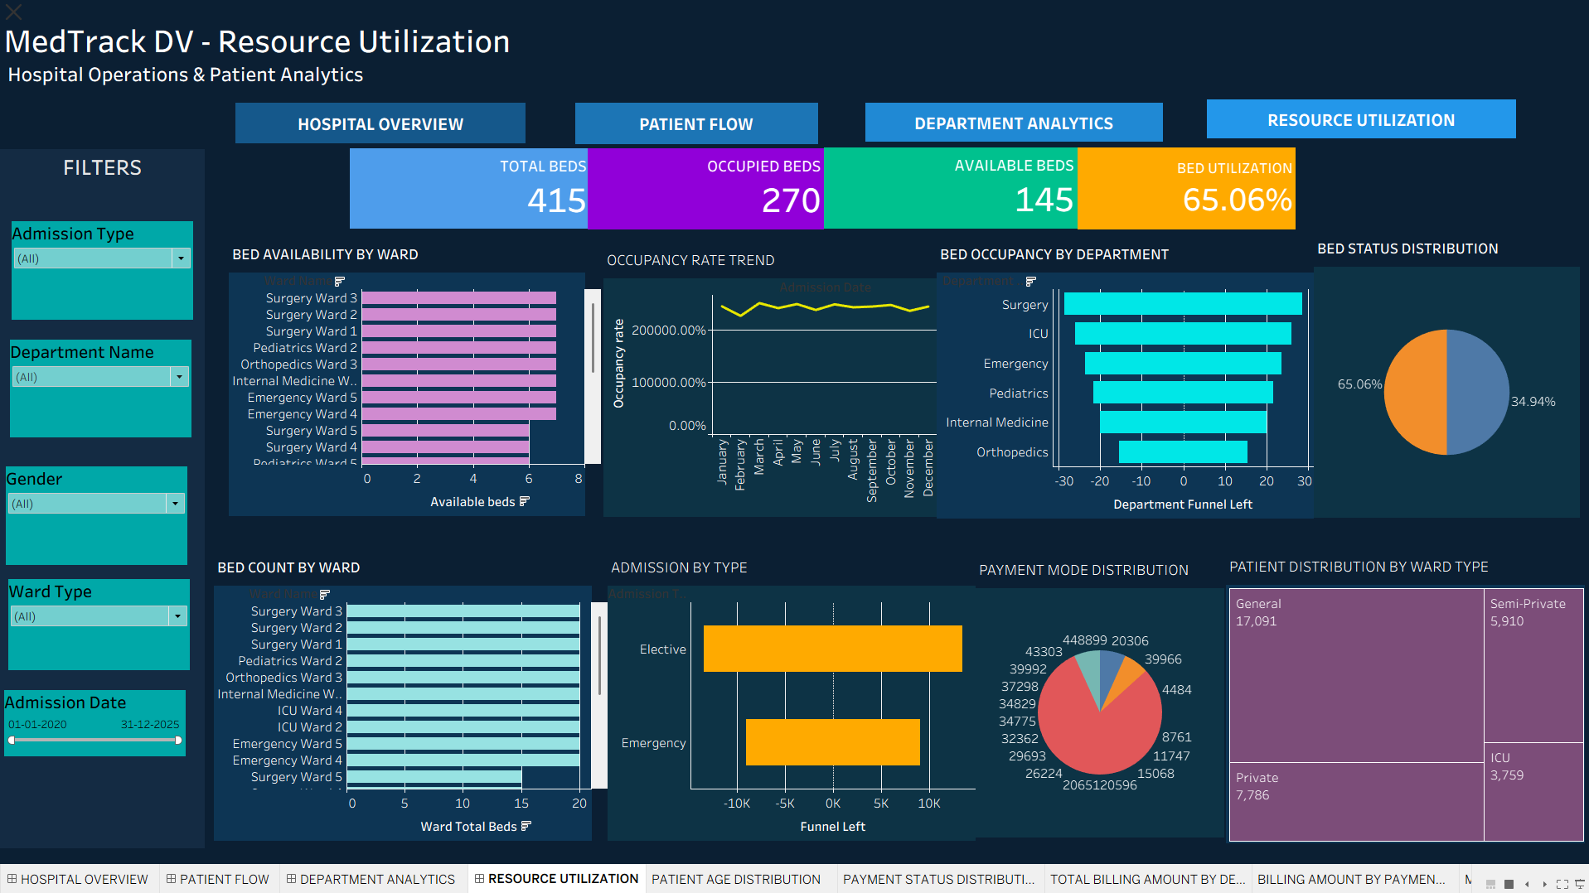
Fig:4

11.DASHBOARD NAVIGATION

Dashboard Navigation
To make the MedTrack DV report easier to explore, a common navigation bar was added at the top of all four dashboards. The navigation provides direct access to the major sections of the project:
- Hospital Overview — Provides an overall view of hospital operations, admissions, beds, readmissions, and billing.
- Patient Flow — Focuses on admissions, discharges, patient movement, length of stay, and patient trends.
- Department Analytics — Compares department-wise patient volume, revenue, LOS, admission patterns, and efficiency.
- Resource Utilization — Focuses on bed capacity, availability, occupancy, ward utilization, and payment modes.

The navigation buttons were created using Tableau Dashboard Navigation, with each button configured to open its corresponding dashboard. This provides a consistent navigation experience throughout the project and allows users to move between dashboards without manually returning to the workbook or dashboard selection screen.

Interactive Filtering
In addition to navigation, the dashboards use common filters such as Admission Type, Department, Gender, Ward Type, and Admission Date. These filters allow users to interactively change the displayed analysis and focus on specific categories or time periods.

Navigation Flow
Hospital Overview → Patient Flow → Department Analytics → Resource Utilization

The navigation can also be used to move back to any previous dashboard, making the complete dashboard set easy to explore.

12.KEY FINDINGS

Key Findings
The analysis of the cleaned hospital dataset and the four Tableau dashboards provided several important insights into hospital operations.
- High Admission Volume: The dataset contains 45,000 admissions, providing a substantial basis for analyzing hospital activity and patient flow.
- Patient Repetition: The readmission rate is 56.92%, indicating that a significant proportion of patients had more than one recorded admission.
- Bed Utilization: The hospital has 415 beds, with 270 occupied and 145 available, resulting in a 65.06% bed utilization rate.
- Emergency Admissions: Emergency cases account for approximately 40.17% of total admissions, showing a considerable demand for urgent hospital services.
- Average Hospital Stay: The overall average length of stay is 5.16 days, while the ICU has a substantially higher average stay of approximately 9.98 days.
- Departmental Volume: Surgery has the highest admission volume, with 10,126 admissions, making it the highest-volume department in the dataset.
- Payment Patterns: Insurance is the dominant payment mode, accounting for approximately 79.95% of admissions, while the remaining payments are distributed among UPI, card, and cash.
- Financial Analysis: Department-wise billing visualizations help identify differences in revenue contribution and provide a financial perspective on hospital operations.

Overall Insight
The dashboards bring together patient flow, departmental performance, resource utilization, and financial information into one interactive analytical system. This makes it easier to identify operational patterns and compare different areas of hospital performance.

13.CHALLENGES & SOLUTIONS

Challenges & Solutions
During the development of the MedTrack DV project, several challenges were encountered while working with the dataset, data-cleaning process, and Tableau dashboards.
Challenge | Solution
Raw dataset required refinement | The dataset was inspected and cleaned using Python and Pandas in Jupyter Notebook before visualization.
Inconsistent or unsuitable data fields | Important fields were checked for data types, unique values, duplicates, and consistency before being used in Tableau.
Creating calculated KPIs | Tableau calculated fields and appropriate aggregations such as COUNTD, AVG, and SUM were used to create the required KPIs.
Representing certain Power BI visuals in Tableau | Alternative Tableau techniques such as Gantt-based funnels and area-chart approximations were used where an exact native visual was unavailable.
Maintaining dashboard consistency | A common dark-theme design, filter panel, KPI style, and navigation bar were maintained across all four dashboards.
Making dashboards interactive | Filters and dashboard navigation were configured so users could explore different departments, admission types, genders, ward types, and dates.

Overall Challenge
One of the main challenges was translating the reference dashboard designs into Tableau while maintaining accurate values from the cleaned dataset. The project required both data-analysis understanding and practical knowledge of Tableau's visualization and dashboard features.

Solution Approach
The challenges were addressed through data validation, calculated fields, appropriate aggregations, Tableau formatting, and repeated testing of dashboard visuals. This helped ensure that the final dashboards were both interactive and based on the refined hospital dataset.

14.CONCLUSION

The MedTrack DV – Hospital Operations & Patient Analytics project successfully demonstrates the complete process of transforming raw hospital data into meaningful and interactive analytical dashboards. The project began with the collection of a hospital dataset from Kaggle, which was then studied to understand its structure, attributes, and relevance to hospital operations.
The raw dataset was refined using Python, Pandas, and Jupyter Notebook. Data cleaning and validation were important steps in ensuring that the dataset was consistent, structured, and suitable for analysis. Different aspects such as duplicate records, data types, categorical values, numerical fields, admission information, patient details, hospital resources, and financial information were reviewed during the refinement process. The final cleaned dataset was then used as the foundation for visualization.
Using Tableau, four interactive dashboards were developed: Hospital Overview, Patient Flow, Department Analytics, and Resource Utilization. Each dashboard was designed to address a different aspect of hospital operations. The dashboards use a combination of KPI cards, line charts, bar charts, area charts, pie charts, treemaps, scatter plots, funnel-style visualizations, and waterfall visualizations to present information in an easily understandable format.
The project also provided practical experience in creating calculated fields, aggregations, interactive filters, dashboard layouts, navigation buttons, and consistent visual themes. The common navigation system allows users to move between the four dashboards, while filters provide the ability to explore the data based on admission type, department, gender, ward type, and admission date.
The analysis provided useful insights into hospital operations, including 45,000 admissions, 23,275 unique patients, a 5.16-day average length of stay, 65.06% bed utilization, and a 40.17% emergency admission rate. Department-level analysis also highlighted differences in patient volume and length of stay, while resource and payment visualizations provided additional operational and financial perspectives.
Overall, this project helped demonstrate how data analysis and data visualization can convert complex healthcare data into clear, interactive, and useful information. It also provided practical experience in working through the complete data analytics workflow—from data collection and cleaning to visualization, dashboard development, analysis, and presentation. The MedTrack DV dashboards therefore serve as a consolidated analytical view of hospital operations and demonstrate the value of visualization in understanding patterns and supporting data-driven decision-making.

15.REFERENCES

References
The following resources and tools were used during the development of the MedTrack DV – Hospital Operations & Patient Analytics project:
- Kaggle — Used as the source for the raw hospital dataset.
- Python — Used for data preprocessing, cleaning, and validation.
- Pandas Documentation — Used as a reference for data manipulation and analysis.
- Jupyter Notebook — Used for dataset inspection, cleaning, refinement, and validation.
- Tableau — Used for data visualization, calculated fields, KPI creation, interactive filters, dashboard design, and navigation.
- Tableau Documentation — Used as a reference for dashboard, worksheet, calculated-field, and visualization features.
- GitHub — Used for organizing, storing, and submitting the project work module-wise.

Project Resources
- Raw hospital dataset obtained from Kaggle
- Refined dataset: hospital_cleaned.csv
- Jupyter Notebook used for data cleaning and validation
- Tableau workbook containing the four MedTrack DV dashboards
- Dashboard reference/storyboard used for maintaining the required visual structure and design

